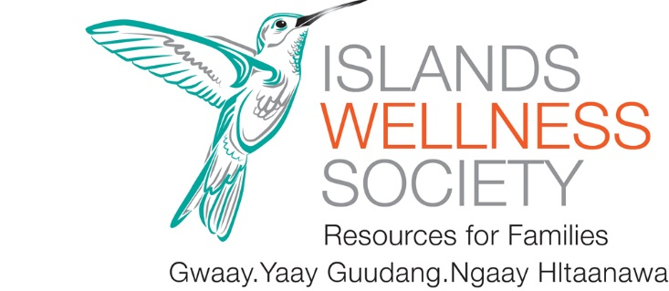
JOB OPPORTUNITY!
Prevention, Education, Advocacy, Counselling, and Empowerment Program (PEACE)
CHILD AND YOUTH COUNSELLOR.
Position: PEACE Counsellor, Permanent Part-time
Hours of Work: Part-time: 18.5-20 hrs/wk. With possibility for extension of work hours..
Start Date: ASAP
Worksite: Islands Wellness Society-207 Oceanview Drive, Daajing Giids, BC. We are a small but mighty feminist, consensus-based community organization.
Wage: 32.00-38.00 with a generous staff wellness, education, and benefits package.
- Wage commensurate with experience
Job Summary
The PEACE counsellor provides individual and group psycho-educational counselling, education and advocacy support to children and youth who have been impacted by violence. Eligible participants in the PEACE program are children and youth between the ages of 3 and 18 years of age who reside in Daajing Giids, Skidegate and surrounding areas. The PEACE counsellor also provides emotional and parenting support for parents/guardians regarding the impact of violence and trauma on the children and youth under their care.
Qualifications
Education, training, and experience
- Bachelor’s Degree in a related human/social service field.
- Sound knowledge and understanding of gender-based violence.
- Minimum 2 years related experience.
- Or an equivalent combination of education, training, and experience.
- Excellent verbal and written communication skills.
- Computer skills and knowledge of applicable software and internet programs (Word, Excel, Outlook, Teams)
- Demonstrated ability to work independently and as part of a team. Self-motivated and organized.
- Demonstrated knowledge of First Nations culture and Haida community is an asset.
- Knowledge of community-based programs, services, and related provincial and community support systems.
- Knowledge of the justice system, family law, mental health, poverty, tenants’ rights, worker’s rights, and related statutes.
- Satisfactory Criminal Records Check.
- Adheres to the constitution, philosophy, policies and procedures, code of ethics of the Islands Wellness Society.
- Own a vehicle (including insurance to/from work with minimum 1 million liability) and possess a valid driver’s license. The program will provide an upgrade to “business use” and 2 million liability insurance).
- Some work may be required outside of normal office hours.

Job skills and Abilities
- Understanding and experience of the context and impact of intimate partner violence.
- Familiarity with child protection legislation and the anti-violence advocacy needs of children.
- Demonstrated knowledge and skill in understanding and working with the impact of violence and abuse on children.
- Skilled in individual psycho-educational counselling and group process/facilitation techniques; skilled in teaching safety techniques and providing advocacy services.
- Demonstrated approach that is compassionate, respectful, and client-centred that fosters dignity, individuality, and decision- making processes for clients.
- Excellent oral, written, facilitation and interpersonal communication skills.
- Effective interviewing and assessment skills.
- Effective time management skills.
- Ability to work effectively with community service providers.
- Excellent conflict resolution skills.
- Demonstrates critical, innovative, and strategic thinking.
- Works in a respectful and cooperative manner with staff and clients.
Summary of Duties and Responsibilities
- Conduct individual and group therapeutic programs as needed.
- Maintain records according to current counselling standards in BC.
- Maintain and report program statistics to the Government of BC
- Plan and maintain budget in coordination with the Finance Coordinator at IWS
- Attend monthly staff meetings. (First Thursday of each month from 10AM-1PM).
- Coordinate with local partners such as SD50, Northern Health, Ministry of Child and family development (MCFD), Skidegate health Centre, and Haida Child and Family Services.
- Keep all client information confidential.
About the Islands Wellness Society
The Islands Wellness society (IWS) is an inclusive community-based agency that provides a variety of services in a safe and supportive environment. IWS respectfully acknowledges that we are located on the unceded and traditional territory of the Haida Nation. Our services endeavor to promote empowerment, overcome trauma, address violence, promote equality and enrich the lives of children and families on Haida Gwaii.
To Apply
Please forward cover letter and resume to Wendy Watts at counselling@islandswellnesssociety.com. Position will remain open until filled. Only those candidates who have been shortlisted for an interview will be contacted.
If you have questions, please email the above address.

